Build a container
--> Using the URL http://node1.net2.example.com/container/Containerfile to build the container image with the name "watch".
--> Do not modify the container file
--> use sia user to build the image, password will be “redhat”
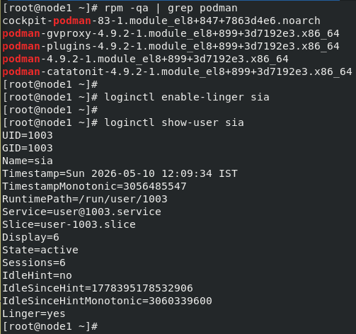
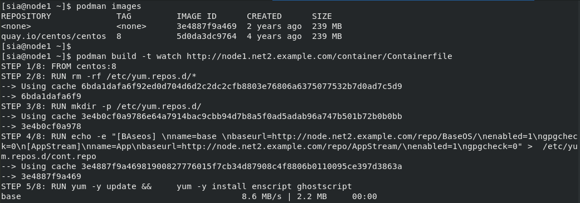
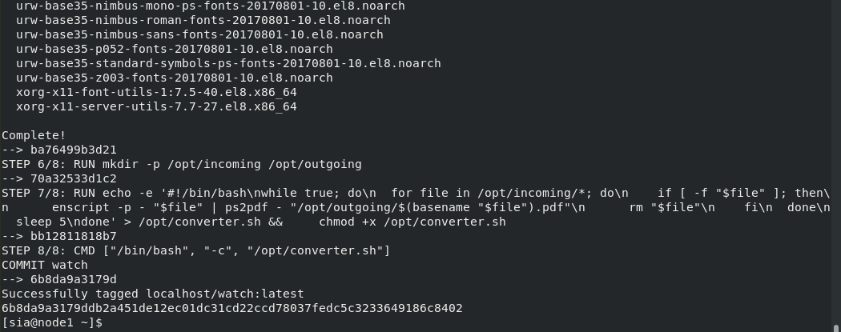
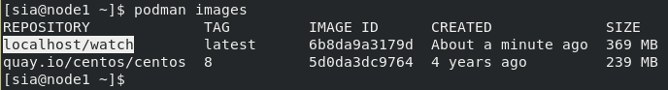

Working with container
a) Create the container name as ascii2pdf as sia user.
b) Run the container by using image watch which one was already done in previous
c) Create the container as a system start-up service, While reboot it will automatically start the service without any human intervention.
d) The system service should be container-ascii2pdf
e) The local directory /opt/files should be persistently mount on container’s /opt/incoming directory
f) The local directory /opt/processed should be persistently mount on container’s /opt/outcoming directory.

NOTE: In working of service starts, any file create/store under the /opt/files automatically creates into pdf on /opt/outcoming directory.

